Do’s:

1.Install Visual studio (net 6.0 version).

2.download Google Chrome and install.

3.Check google version. (Open Google chrome 🡪settings🡪 About Chrome)  
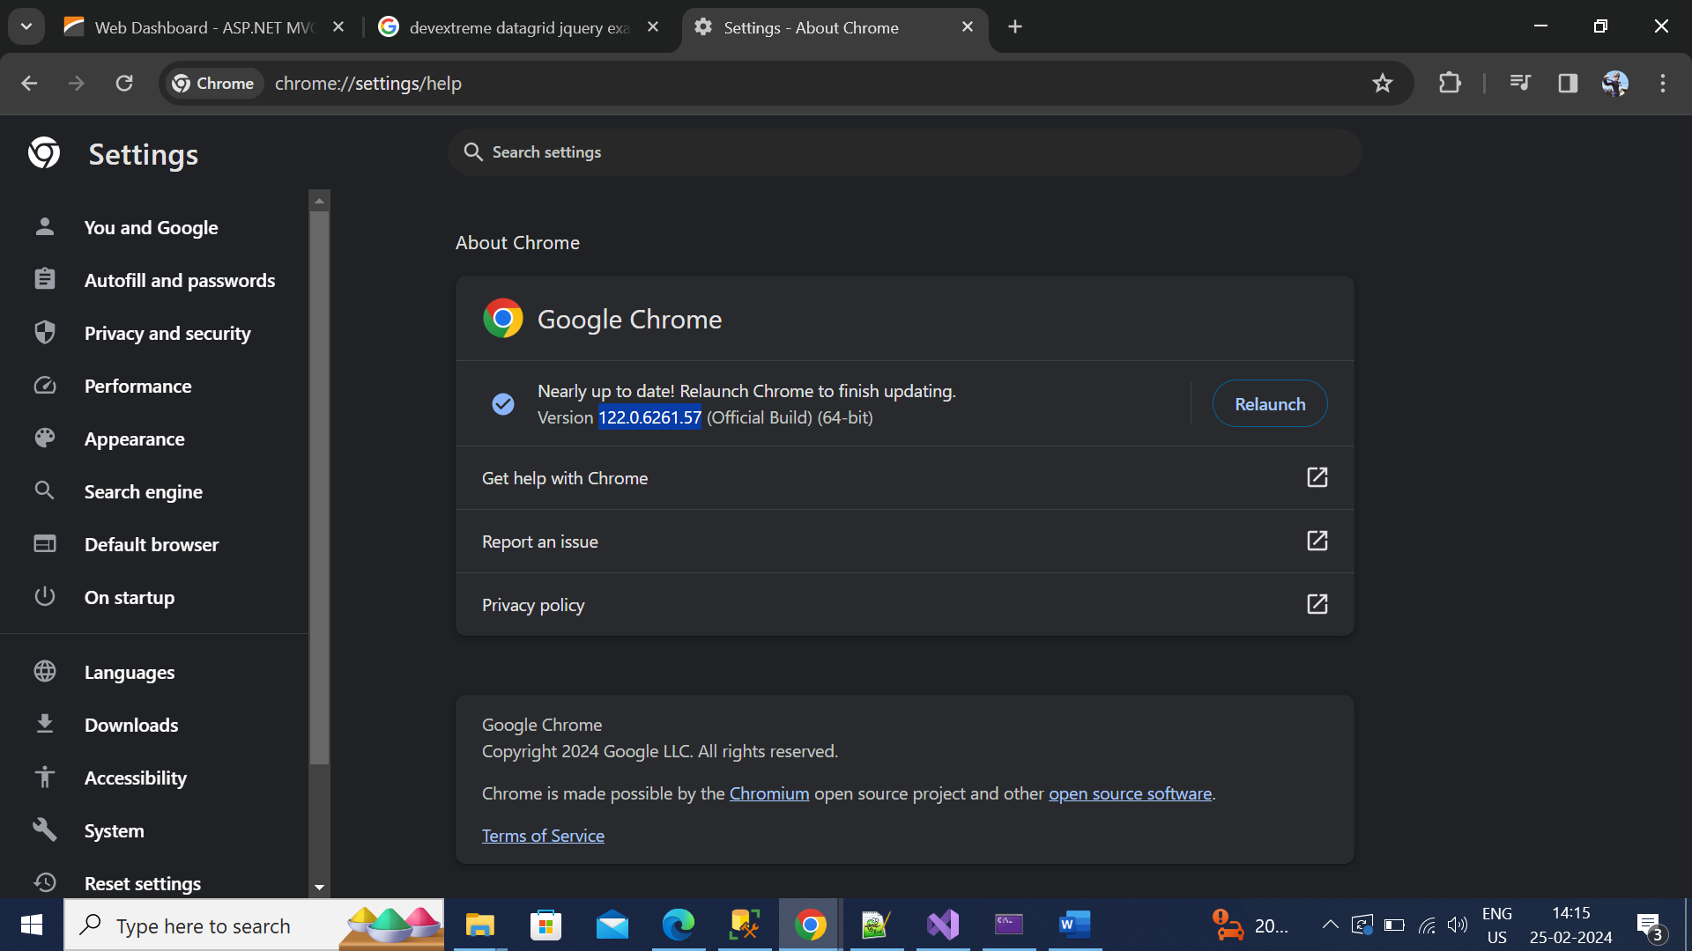

4. <https://googlechromelabs.github.io/chrome-for-testing/> go to this link and find chrome version 🡪chromedriver -> win64 -> copy the url and downlod the file into downloads folder itself.

5. Extract the downloads zip file into downloads folder itself.



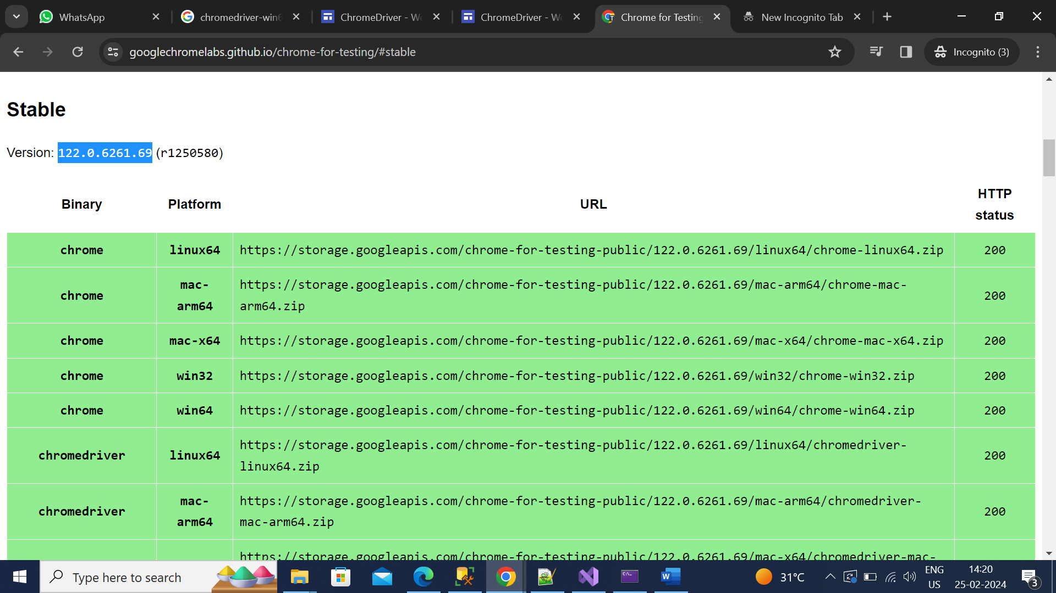

6. line number 487 –need to change extract file location here.

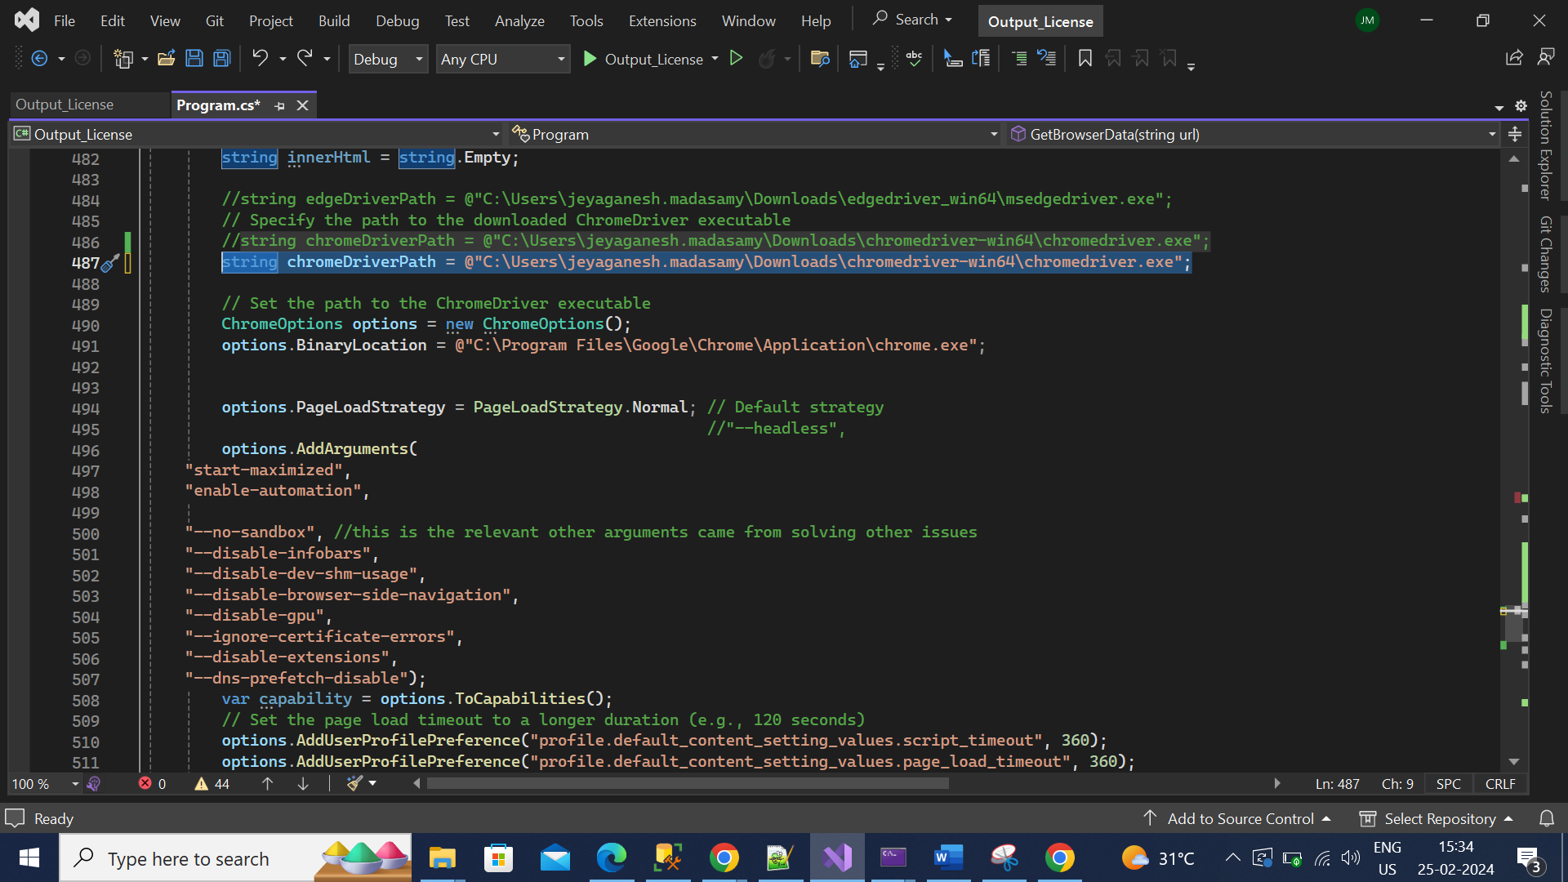

7. line number 407 and 424 output excel which location you want that location need to change.   
  
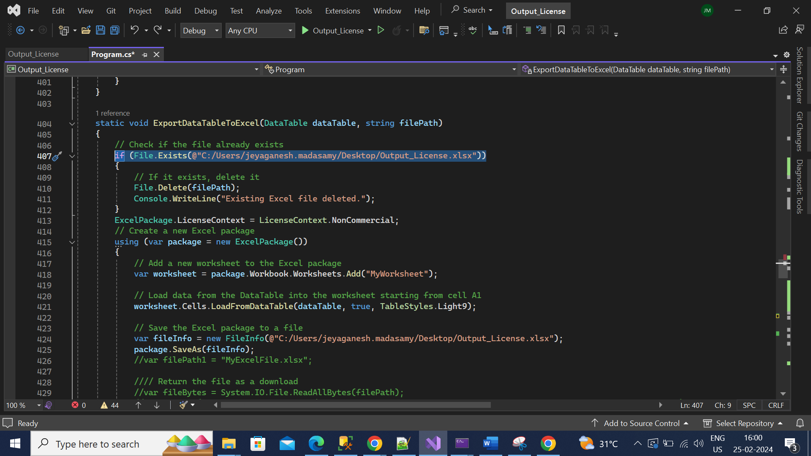

8. line number 70 , 208 you can replace starting number example (<https://mypvl.dcca.hawaii.gov/public-license-details/?licenseId=CT-208-0>).  
I<=2000 here 2000 you replace end download file number, if you given 2000 then 2000 records downloads.   
